SACRED HEART PARISH

Sacred Heart Parish Founded 1814, The First Catholic Parish in the STate of New Jersey

Sacred Heart Church, 343 South broad Street, Trenton, New Jersey 08608

Holy Cross Church, 233 Adeline Street, Trenton, New Jersey 08611

ALL ARE WELCOME

Whatever your present status in the Catholic Church, whatever your current family or marital situation,

Whatever your past or present religious affiliation, whatever your personal history, age, background, or

race, whatever your own self-image or esteem, you are invited, welcomed, accepted, loved and

respected at the Parish of the Sacred Heart.

PASTOR

Rev. Msgr. Dennis A. Apoldite
frdennis@trentonsacredheart.org
PAROCHIAL VICAR
Rev. Charles Muorah
Felician Residence for Clergy
233 Adeline Street, Trenton, New Jersey 08611
609-393-4826 ext. 108 for Fr Charles
DEACON
Dr. Christian Nnajiofor

Business ADMINISTRATOR
ADMINISTRATIVE ASSISTANT
John DeSantis: secretary@trentonsacredheart.org
Administrator of religious education
Mary Tovar: reled@trentonsacredheart.org
COORDINATORS OF SACRED MUSIC
Natalie Megules ~ 609-575-6484
Rupert Peters ~ Gospel Mass 609-442-7871
MAINTENANCE DEPARTMENT
Frank Rios
Trustees
Jack Breuer and Ellieen Ancrum Ingbritsen,

OFFICE HOURS

9:00am – 4:00pm Monday – Friday

SACRED HEART PARISH OFFICE

343 South Broad Street, Trenton, NJ 08608

Phone: (609) 393-2801 ~ Fax: (609) 989-8997

WEB PAGE:

www.trentonsacredheart.org

CEMETERY RECORDS
Contact The Office of Catholic Cemeteries at 609-394-2017 or DirectorofCemeteries@DioceseofTrenton.org

SACRAMENTAL RECORDS
Sacred Heart Church, Saint John’s Church, Saint Francis Church, Saints Peter and Paul Church, Saint Stanislaus Church, Holy Cross Church, Blessed Sacrament Church, Our Lady of Divine Shepherd Church, Blessed Sacrament/Our Lady of Divine Shepherd Parish and Divine Mercy Parish.

Liturgy Schedule

Sacred Heart CHURCH
Monday, Tuesday, Wednesday and Friday
12:10 Noon
Saturday Evening 5:15 PM
Sunday Morning 9:00 and 11:15 AM
HOLY CROSS CHURCH
Monday, Thursday and Friday 8:00 AM
Saturday Evening 4:00 PM
Sunday Morning 10:00 AM Gospel
12:00 Noon Polish
For each Holy Day please reference the bulletin

SACRAMENTS
BAPTISM
Please call the Parish Office at least one month in advance.

RECONCILIATION

Every First Friday following the 12:10PM Mass SHC

Saturday afternoon ~ 4:30 to 5:00 PM SHC

Every Saturday from 3:30 to 3:50 PM HCC

Every Sunday 9:30 to 9:50AM HCC

and by appointment.
EUCHARISTIC ADORATION
First Saturday of the Month 2:30 to 3:30 pm
in Holy Cross Church
MARRIAGE
Please call the Parish Priest at least one year in advance to set up initial meeting and to confirm a wedding
date and time.
ANOINTING OF THE SICK
Please call the Priests any time 609-393-2801.
COMMUNION TO THE HOMEBOUND
Call the Parish Office to schedule home visit.
CONSIDERING PRIESTHOOD?
Email: Vocations@DioceseofTrenton.org

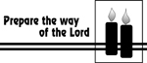
SECOND SUNDAY OF ADVENT
DECEMBER 10, 2023

MASS INTENTIONS
Saturday, December 9
4:00 pm~ Dolores Krysztofik and Mieczyslaw Konecki
5:15 pm SHC ~ Ken and Lucille Fisher
Sunday, December 10
9:00 SH ~ Hoch & Ridorfino Families
and Holy Name Society
10:00 HCC ~ Intentions of the People of the Parish
11:15 SHC ~ Alice Feehan
12:00 HCC Polish~ Stanislaw Tylutki & Grazyna Brown
Monday, December 11
8:00 am HCC ~ Donald J. Manger
12:10 pm SHC ~ Diana Cracker Amoroso
Tuesday, December 12
12:10 pm SHC ~ Henry Welling Lane
Wednesday, December 13
12:10 pm SHC ~ Edward Kostrzewa
Thursday, December 14
8:00 am HCC ~ Philomena and William Cracker
Friday, December 15
8:00 am HCC ~ Helen Covaleski
12:10 pm SHC ~ Sally Kuser Lane
Saturday, December 16
4:00 pm~ Deceased members of the Littwin Family
5:15 pm SHC ~ Victor and Silvana Ladnyk
Sunday, December 17
9:00 SH ~ Ann Marie Lammerding
10:00 HCC ~ Intentions of the People of the Parish
11:15 SHC ~ Patrick Sheehan
12:00 HCC Polish~ Deata Mlodorzenice

OUR SICK LIST
Kristen Topley, Mary Sokolowski, Rocco, Lorraine Wargo, Robert Paci, Mrs. Loatman, David Carver, Jennifer Lyons, Grace Profy, Steve Jurczynski, Cornell Hess, Ruby Covington, Judith Santigo, Ching Kukis, Dan Breese Jr, Brenna Kennedy-Moore, Dawn Chia, Mark Friedman, Alexander A. Ladnyk, Kelly Nitti, Lauren Clayton, Joseph Edralin, Margie Tiongson, Kevin, Vincent Cooper, Jr., Gail Ladnyk, Leo Genovesi, Sloane Donnelly, Richard Buckley, Tony Ragolia, Barbara Burrows, Charles Burrows, Dorothy Amoroso, Maryann Sullivan, Regina Friedman, Stanley Winowicz, Greg Schafer, Jack Hardiman, Amy Birk, Julia Grazioli, Matt Tydryszewski.

OUR DECEASED
Robin Haynes, Betty O’Neill, Susan Cuniglio, Rafael Whitfield and our friends at South Village, Riverside Nursing and Rehabilitation Center, Mill House and Waters Edge.

MINISTRY SCHEDULE
(subject to change)
Saturday, December 9
4:00pm HCC ~ Msgr. Dennis L. V. Zielinski Em. A. Lennon
5:15pm SHC ~ Msgr. Dennis L. L. Seabrook Em. S.&K. Farruggio
Sunday, December 10
9:00 Msgr. Dennis L. M. Komjathy Em. O. Nagbe & E. Wengryn
10:00 HCC ~ Msgr. Dennis L. R. West Em. V. Kamah
11:15 ~ Msgr Dennis L. J. Blizard Em. K. Parasimo & B. Allaire
12:00 HCC Polish ~ Fr Marian Gosia, Ewa

Saturday, December 16
4:00pm HCC ~ Fr Charles L. M. Herpel Em. R. Micharski
5:15pm SH Msgr. Dennis L. R Hernandez Em. W. Lewis & T. Hines
Sunday, December 17
9:00 SHC ~ Msgr. Dennis L. J. McDonough Em. A. & C. Cruz
10:00 HCC ~ Fr. Charles L. A. Dodson Em. M. Williams
11:15 SHC ~ Msgr Dennis L. J. Laurenti Em. B. Dumont & J. Bautz
12:00 HCC Polish ~ Fr Charles Anna, Mieciu

WEEKLY COLLECTION
Last weekend’s collection amounted to $10,289.00. Thank you for your continued support of our parish.

2023 ANNUAL CATHOLIC APPEAL UPDATE
Goal: $33,000.00
Pledged: $46,592.00 (141% of Goal)

READINGS FOR THE WEEK
Second Week of Advent
Sunday Is 40:1-5, 9-11; 2 Pt 3:8-14; Mk 1:1-8
Monday Is 35:1-10; Lk 5:17-26
Tuesday Zec 2:14-17 Lk 1:26-38
Wednesday Is 40:25-31; Mt 11:28-30
Thursday Is 41:13-20; Mt 11:11-15
Friday Is 48:17-19; Mt 11:16-19
Saturday Sir 48:1-4, 9-11; Mt 17:9-13

PROMISE TO PROTECT
The Diocese of Trenton is committed to the norms of the U.S. Bishop’s Charter for the Protection of Children and Young People in regard to the reporting and investigation of sexual abuse allegations involving minors. If you have been sexually abused as a minor by anyone representing the Catholic Church, you can report that abuse through the diocesan Hotline: 1-888-296-2965 or abuseline@dioceseoftrenton.org. Allegations are reported to the appropriate law enforcement agencies.
2024 CALENDARS
Our 2024 Calendars have arrived and are available in the vestibule of our Churches.

OUR GIVING TREE PROJECT
All gifts are due back this weekend. Please wrap the gift and secure the tag to the gift. All gifts will be picked up by the agencies on Monday morning December 11th Thank you for sharing your Christmas Joy with the needy in our greater Trenton area.

RELIGIOUS RETIREMENT COLLECTION
This weekend, December 9th and 10th a second collection will be taken up for the Religious Retirement Fund. We ask for your generosity with this non-diocesan collection which will benefit those priests, sisters and brothers who have dedicated their lives to the service of the church.

BLOOMIN’ 4 GOOD PROGRAM
Sacred Heart’s Food Outreach Program has been selected by Stop & Shop to benefit from the Bloomin’ 4 Good Program. Our food pantry will receive $1 from every specially marked $10.99 Bloomin 4 Good bouquet sold during the month of December 2023 at the Stop & Shop located at 800 F Denow Road, Pennington NJ.

BLESSING OF THE INFANT JESUS
On Sunday, December 17th we ask that all of the Children of the parish attend the Family Mass at 11:15am Sacred Heart Church. We ask that they bring the baby Jesus from your nativity set so that the Infant may be blessed. If you do not have a nativity set please be creative with your children and make one with them or bring in a picture. Our Religious Education students will present “the Nativity” story for us.

FOOD OUTREACH PROGRAM
Food Collection Weekend is scheduled for December 16th and 17^{th.} Food Bagging will be held on Monday, December 18th at 9:30am in Toomey Hall, with Food Distribution on Tuesday, December 19th at 1:30pm. Your help is greatly needed and appreciated.

CHRISTMAS SCHEDULE 2023

SACRED HEART CHURCH
Saturday, December 23
5:15 PM Vigil Mass
Sunday, December 24
10:00 AM
The Nativity of the Lord ~ CHRISTMAS EVE
4:15 PM Christmas Presentation
in Word and Song
5:15 PM and 12:00 Midnight Mass
Monday, December 25 ~ CHRISTMAS DAY
9:00 AM and 11:15 AM
Tuesday, December 26 No Mass

HOLY CROSS CHURCH
Saturday, December 23
4:00 PM Vigil Mass
Sunday, December 24
10:00 AM and 12:00 Noon Polish
The Nativity of the Lord ~ CHRISTMAS EVE
4:00 PM
Monday, December 25 ~ CHRISTMAS DAY
10:00 AM Gospel and 12:00 Noon ~ Polish

NEW YEAR SCHEDULE
SACRED HEART CHURCH
Saturday, December 30 5:15 PM Vigil Mass
Sunday, December 31 10:00 AM
Feast of Mary, Mother of God ~
NEW YEAR’S EVE
Sunday, December 31 5:15 PM
Monday, January 1 ~ NEW YEAR’S DAY 10:00 AM

HOLY CROSS CHURCH
Saturday, December 30 4:00 PM Vigil Mass
Sunday, December 31
10:00 AM and 12:00 Noon
Feast of Mary, Mother of God
Sunday, Dec. 31 NEW YEAR’S EVE 4:00 PM
Monday, January 1 ~ NEW YEAR’S DAY
10:00 AM Gospel Mass
12:00 Noon Polish Mass

BLESSING OF HOMES
The Blessing of Homes will take place this year during the month of January. The Blessing includes a prayer that God will protect your family during the coming year. Your home will sprinkled with holy water and the initials of the Three Kings who visited and worshipped the Infant Jesus in Bethlehem are written above the lintel of the main door with blessed chalk (Caspar, Melchior, and Balthasar). The Blessing of Homes will begin the second week of January. If you are a registered parishioner and wish to have your home blessed, please complete the form below and return it in the collection basket or drop it off at the Parish Office.
Name __________________________________________
Address___________________________City________
Cell or phone number __________________

VOLUNTEER PARTY
The “Little Christmas” Volunteer Appreciation Party, will be held Friday evening, January 5th from 6:00 - 9:00 pm. We will begin with a prayer service at 6:00 pm in Sacred Heart Church followed by light refreshments in Msgr. Toomey Hall. All those who volunteer as Finance Council, Trustees, Ushers, Choir Members, Lectors, Ministers of the Eucharist, Altar Servers, RCIA Team, Catechists, Caregivers, Food Distribution & The Lord’s Table, Collection Counters, Parish Staff and all other volunteers are invited. Please R.S.V.P. by December 28th by calling the office at 609-393-2801 or by filling out the form below and place in the collection basket. Thank you.
VOLUNTEER PARTY
Name _______________________________
Number attending______________________
Cell or phone number __________________

CHRISTMAS FLOWER ENVELOPE
The Christmas Flower collection envelope can be place with the regular collection when it is appropriate for you to contribute. Thank you.

SECOND SUNDAY OF ADVENT

~ THE SECOND CANDLE ~
Prepare the way of the Lord, make straight the path! We hear the voice of John the Baptist calling us to prepare our hearts to greet the Lord. “Reform your lives, the reign of God is at hand,” he says. In other words, straighten out your crooked ways and make your rough places smooth. You too are a herald of God’s reign. Make peace, give comfort, be patient. Cry out with your deeds: “Our God is coming! Prepare the way.” (Light two purple candles.)
Scripture: “May God, the source of all patience and encouragement, enable you to live in perfect harmony with one another according to the spirit of Christ Jesus, so that with one heart and voice you may glorify God”
Prayer: Jesus, you are the light of the world. May the fire of your love burn away our sins. May it help us to prepare the way for you by being kind, forgiving and fair. Response: Come, Lord Jesus!

“AMAHL AND THE NIGHT VISITORS”
is an uplifting, inspirational opera of two children joined by faith on the eve of the Nativity. A poor mother and her disabled son, Amahl, who has a penchant for tall tales, open their humble home to the Three Kings on their westward,
star-guided quest. You and your family can see “Amahl and the Night Visitors” Sunday, December 10th, 6:00PM at the Church of St. Gregory the Great in Hamilton Square; and Saturday, December 16th 6:00PM at Saint David the King Church in Princeton Junction.
TICKETS Adults: $30
Children 12 & Under: FREE
Special Note: Although children aged 12 and under will be admitted for free, tickets are required for them so we can monitor the number of children 12 and under who attend the performance. tickets/information, visit:
https://www.bohemeopera.org/amahl-and-the-nightvisitors

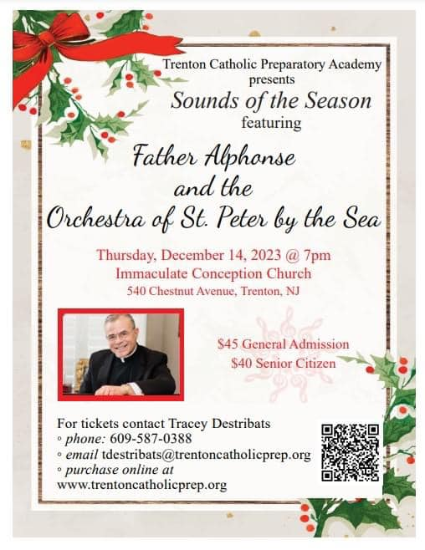

PRAYER TO OUR LADY OF GUADALUPE
PATRONESS OF MEXICO
We turn to you, Our Lady of Guadalupe, and ask that you bring hope to our troubled world. As you did in 1531, make God’s love and compassion known to us today. Open the eyes of the leaders and the comfortable so that they will recognize their responsibility to care for the less fortunate and the poor. Open the hearts of the downtrodden, fill them with the warmth of God’s love and give them hope in tomorrow. Help us all to follow your Son’s call to love one another as He has loved us. Amen.

MARY SUSTAINS OUR WAITING FOR GOD
“Mary sustains our journey toward Christmas, for she teaches us how to live this Advent Season in expectation of the Lord. For this time of Advent is a time of waiting for the Lord, who will visit us all on the feast, but also, each one, in our own hearts. The Lord is coming! Let us wait for him!”
~ Pope Francis
SAINT LUCY’S STORY
FEAST DAY DECEMBER 13
Every little girl named Lucy must bite her tongue in disappointment when she first tries to find out what there is to know about her patron saint. The older books will have a lengthy paragraph detailing a small number of traditions. Newer books will have a lengthy paragraph showing that there is little basis in history for these traditions. The single fact survives that a disappointed suitor accused Lucy of being a Christian, and she was executed in Syracuse, Sicily, in the year 304. But it is also true that her name is mentioned in the First Eucharistic Prayer, geographical places are named after her, a popular song has her name as its title, and down through the centuries many thousands of little girls have been proud of the name Lucy.
One can easily imagine what a young Christian woman had to contend with in pagan Sicily in the year 300. If you have trouble imagining, just glance at today’s pleasure-at-all-costs world and the barriers it presents against leading a good Christian life.
Her friends must have wondered aloud about this hero of Lucy’s, an obscure itinerant preacher in a far-off captive nation that had been destroyed more than 200 years before. Once a carpenter, he had been crucified by the Romans after his own people turned him over to their authority. Lucy believed with her whole soul that this man had risen from the dead. Heaven had put a stamp on all he said and did. To give witness to her faith she had made a vow of virginity.
What a hubbub this caused among her pagan friends! The kindlier ones just thought her a little strange. To be pure before marriage was an ancient Roman ideal, rarely found, but not to be condemned. To exclude marriage altogether, however, was too much. She must have something sinister to hide, the tongues wagged.
Lucy knew of the heroism of earlier virgin martyrs. She remained faithful to their example and to the example of the carpenter, whom she knew to be the Son of God. She is the patroness of eyesight.

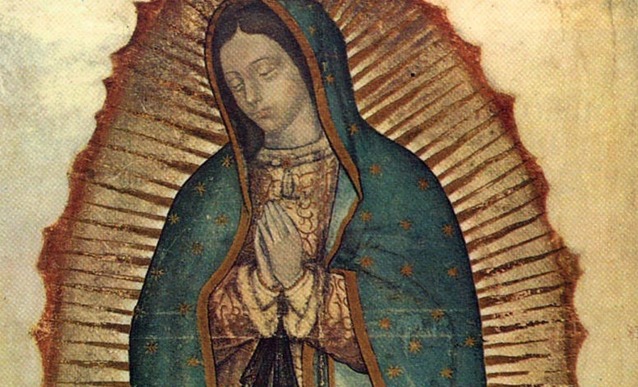
THE STORY OF OUR LADY OF GUADALUPE
FEAST DAY DECEMBER 12
The feast in honor of Our Lady of Guadalupe goes back to the 16th century. Chronicles of that period tell us the story.
A poor Indian named Cuauhtlatohuac was baptized and given the name Juan Diego. He was a 57-year-old widower, and lived in a small village near Mexico City. On Saturday morning December 9, 1531, he was on his way to a nearby barrio to attend Mass in honor of Our Lady.
Juan was walking by a hill called Tepeyac when he heard beautiful music like the warbling of birds. A radiant cloud appeared, and within it stood an Indian maiden dressed like an Aztec princess. The lady spoke to him in his own language and sent him to the bishop of Mexico, a Franciscan named Juan de Zumarraga. The bishop was to build a chapel in the place where the lady appeared.
Eventually the bishop told Juan to have the lady give him a sign. About this same time Juan’s uncle became seriously ill. This led poor Juan to try to avoid the lady. Nevertheless the lady found Juan, assured him that his uncle would recover, and provided roses for Juan to carry to the bishop in his cape or tilma.
On December 12, when Juan Diego opened his tilma in the bishop’s presence, the roses fell to the ground, and the bishop sank to his knees. On the tilma where the roses had been appeared an image of Mary exactly as she had appeared at the hill of Tepeyac.
Reflection
Mary’s appearance to Juan Diego as one of his people is a powerful reminder that Mary—and the God who sent her—accept all peoples. In the context of the sometimes rude and cruel treatment of the Indians by the Spaniards, the apparition was a rebuke to the Spaniards and an event of vast significance for the indigenous population. While a number of them had converted before this incident, they now came in droves. According to a contemporary chronicler, nine million Indians became Catholic in a very short time. In these days when we hear so much about God’s preferential option for the poor, Our Lady of Guadalupe cries out to us that God’s love for and identification with the poor is an age-old truth that stems from the Gospel itself.

